**IMPLEMENTING CORE FUNCTIONALITIES OF PDS USING HYPERLEDGER FABRIC**

**GOKUL E*1, HEMANTH S*2, HARI N *3, DR. G SENTHIL KUMAR*4**

*1,2,3Student, Department of Computer Science and zEngineering, Panimalar Engineering College, Chennai, India

*4Associate Professor, Department of Computer Science and Engineering, Panimalar Engineering College, Chennai, India

**ABSTRACT**

Public Distribution System (PDS) is an essential scheme for food security introduced by Indian Government under the Ministry of Consumer Affairs, Food and Public Distribution. Main purpose of the system is to make sure that edible and non-edible supplies reach to marginalized section of Indian society at subsidized cost. However, PDS is vulnerable to leakages and issues with procurement and storage. Indian Government spends more than Rs. 750 billion for PDS and there are more than 5 lakh Fair Price Shops in India. Computerisation for PDS functionalities and AADHAR Biometrics verification is carried out in many states of India. It is found out that leakages have been mitigated as much as possible. But there are many challenges still unnoticed in PDS like opaque tender procurements, diversion of supplies, negligent wastage accountability and corrupt book adjustments in warehouses. These transparency and accountability related challenges of PDS could be met with distributed immutable ledger framework like Hyperledger Fabric. Asset tracking aids in tamper detection, wastage avoidance and logistics optimization. Proof of Concept on functionalities of PDS using Fabric would imply that blockchain could be adopted in various food supply chains and logistics.

**Keywords:** Blockchain, TNCSC, Hyperledger, RFID and PDS.

1. **INTRODUCTION**

In India, it is estimated that 291.95 million tonnes of food grains were produced in 2019-2020. Out of the above-mentioned number, around 4.6-6% is wasted according to National Academy of Agricultural Sciences. This implies that the loss is around 12-18 million tonnes and experts anticipate that the loss could be higher. 10% of 1000 lakh MT wheat produced every year gets wasted due to improper storage methods. Food Wastage happens in FCI due to various reasons. Food reserves are maintained above the buffer norms at FCI Warehouses. For Example, FCI rice stocks in January 2020 was at 21 MT whereas the actual buffer requirement is 7.6MT. It is also noted that inadequate storage facilities of both central and state government make them to resort to other alternatives like cover and plinth or taking warehouses based upon lease. These alternative measures are found to be the reason for food wastage as edible supplies may get spoiled due to rain, moisture and humidity.

State Governments collaborate with Central Government to implement PDS across the nation. State Governments of India handle PDS in diverging methods as they need to adapt to fulfil the needs of the respective state’s population. This adaption is required due to population dynamics, economics, and food culture. In this paper, Tamil Nadu is taken as example to illustrate the process of PDS. While other states take measures in guise of Targeted Public Distribution System (TPDS) where only marginalized sections are catered, Tamil Nadu is succeeding in eradicating food scarcity through Universal Public Distribution System (UPDS). More than 2 Crore people are getting benefitted through UPDS and there is a network of more than 33,000 Fair Price Shops. UPDS in Tamil Nadu is irrespective of Income Slabs.

In Tamil Nadu, Tamil Nadu Civil Supplies Corporation (TNCSC) is responsible for procurement, storage, and distribution of edible and non-edible supplies through network of Fair Price Shops and Warehouses. TNCSC gets the funds for operations and procurements from State and Central Government. TNCSC procures supplies through various methods. Direct Procurement Centres are designated places where rice and other cereals are procured directly from the farmers by TNCSC. Procurement price is decided by TNCSC at the start of Kharif season. In this process, Farmers register their cultivated paddy produce in the online portal with the help of Village Administrative Officer (VAO) along with land details, bank account details and verification documents like AADHAR. The required authorities will check whether the registered member is a farmer or not by verifying the land details. TNCSC will accept the request based upon their requirements, Farmer will be notified by SMS about procurement details. After the proper weighing and procurement of the cultivated produce, Bank transfer will be initiated by DPC. Staffs at DPC will transfer paddy manually from farmer’s gunny sacks to standard 30kg TNCSC provided gunny sacks. TNCSC provided gunny sacks are stencilled by the staffs at DPC in which details like lot number, farmer token no., variety of paddy is mentioned. But, marking is not done at most cases due to negligence, and this is where accountability misses. Modern Rice Mills (MRM) are state owned, and they have more capacity comparatively whereas Hulling Agents are private agents who are appointed by state government for hulling through tender.

Procured supplies should be within specifications. For example, moisture of the procured paddy should be below 17%. If the paddy has moisture below 17%, then it would be sent to state buffer warehouses for storage otherwise it is rejected. In rainy season, moisture specification is exempted till 20%. In the latter case, paddy would be sent swiftly to Modern Rice Mill (or) Hulling Agent for drying and hulling paddy into rice. If space is not available in buffer warehouses, then Cover and Plinth (CAP) Storage will be chosen. TNCSC gets land for rent and paddy sacks are stored in those open spaces covered by Polypropylene ground (PP) covers (or) Tarpaulin covers. Sacks are stored in cone structure and crisscross manner. Ropes would be tied across the cover, and it is opened on every morning and closed by night for first 10 days and weekly twice for following days afterwards. This makes sure that paddy sack gets enough amount of air to get dried otherwise there are possibility for fungal infections. Pest Control and Fumigation is done in both warehouses and CAP storages. CAP storage is not a suitable method as there are high probability of paddy getting infected and wasted. Warehouses are also checked by quality inspection team of TNCSC to ensure that there is no rodent, pest infestations and no holes in the roof.

These paddy sacks procured are allotted and processed in First Come First Serve (FCFS) way. Hulling agents are chosen in the order by which they have applied and got approved. Security deposit and bank guarantee should be submitted according to the capacity of the mill. Hulling agent’s facility is also inspected by government before the approval, and it is made sure that processing capacity is sufficient, and standards are effectively maintained. After Allotment and Transportation, hulling agent must do the whole process (drying and hulling) within a month. Hulling Agent should reuse the bags provided and if there are excess bags then it should be returned with care to TNCSC. After processing, Rice is sent from hulling agent to state owned warehouses through TNCSC approved tendered transportation.

There are two types of warehouses owned by state government. They are Operational Warehouses and Buffer Warehouses. Buffer warehouse is used to store excess products and Operational Warehouses are used to store supplies which are to be sent to fair price shops. There are two types of rice based upon the treatment. They are boiled rice and raw rice. A Grade and Common are two subtypes within these types.

After Hulling, Rice sacks are sent from MRM (or) Hulling agent’s mill to Operational warehouses. For every 200 bags in consignment from hulling agent, at most 50 bags must be sampled. If the rice sacks are from MRM, then the quality will not be checked at arrival as it is already inspected in MRM before departure. In Warehouse, Sacks are piled up in stack formation and the size of bottom of stack is 30ftx20ft. Poly Filler / Wooden Crates would be the base for stack.

There is another source of procurement for TNCSC (i.e.) FCI Procurement. FCI procures wheat and paddy from various states, and they store it in their central government owned warehouses. As the demand for State Government cannot be met up by supply from DPC, State procures from FCI warehouses. Rice (or) Wheat allotment from FCI procurement is released against payment and FCFS. It acts upon priority basis from divisions which means that the FCI divisional office is responsible for the allocation in a certain jurisdiction of state (i.e.) a part of district. As it is a divisional request, consignment is directly sent from FCI warehouse to Operational warehouse.

There are various movement (i.e.) transportation methods for transferring consignments. Mostly used movement is rail-head transportation. Railways is predominantly used medium for transporting the consignments. It is safer and can carry to a longer range. Another movement is roadway transportation through lorries and trucks. This is used to carry the consignment from one district to another. Lorry Transportation companies are approved and allotted through tenders.

Fair Price Shops are the endpoints through which citizens get essential supplies at subsidized cost. There are two types of Fair Price Shops (FPS) in Tamil Nadu. They are State owned shop and Cooperative shop. State owned shops are mainly found in cities and they are less in number compared to cooperative shops. In case of a cooperative shop, cooperative lead society will perform movement. Deputy Registrar and Joint Registrar are responsible in ensuring that respective cooperative society are functioning properly. Based on the population under an FPS, allotment of essential supplies from warehouse will be given to the FPS on monthly basis.

There are many malpractices and loopholes possible in the system described above. Businesspeople gather paddy and wheat from farmers for a lower rate and provide it to State Government through DPC in guise of farmers. This happens because the registration for farmer at DPC takes more time due to the verification and payment process. Bribe from farmers is asked by staffs at DPC and the staffs are more negligent and reluctant. For example, Load men ask for bribe to carry gunny bags. Due to negligence in procurement, Paddy and Wheat get wasted in rainy seasons. Tender for other essential supplies like Kerosene and Dal varieties are done from other parties and merchants. Tenders are intentionally selected at higher prices than market prices as it paves way for corruption and government bureaucrats get exorbitant bribe. As said earlier, there are many leakages and diversions involved in the system. Hulling agents can manipulate allotted paddy for their personal benefit, and they indulge in diverting fine variety good quality rice. Accountability of consignment is not ensured, and essential supplies are sold in black market to other districts. Mentioned loopholes makes us to aim for a better accountable asset tracking system than the traditional system. [1].

1. **LITERATURE REVIEW**

Bitcoin is a revolution which made the world to conceptualize distributed immutable ledger as Blockchain. In Bitcoin, Blockchain is used to store the transactions in various public peers by reaching consensus through proof of work where every peer competes each other to append block of transactions to the ledger. (Satoshi Nakamoto, 2008). Blockchain acts as a trustful system between various parties which helps in various use cases for eliminating redundancy and unnecessary intermediaries. Decentralized Application, Decentralized Autonomous Organizations are built using blockchain as a trustful framework and Smart Contract on top of it as event-driven code for enabling transactions to happen which serves as backbone for Applications to run based upon it. Broad spectrum of use cases possible using blockchain are FinTech, Health Care, Governance, Intellectual Property Protection, Identity Verification and Supply Chain Management (Melanie Swan, 2015). GUEST (GO, UNIFORM, EVALUATE, SOLVE AND TEST) methodology can be applied to formulate blockchain designs for specific Supply Chain Management and Logistics use case. Comparing Blockchain Frameworks, it narrows down to Hyperledger Fabric for efficient use of Permissioned Blockchain Network (G. Perboli, 2018). [2].

Walmart is solving the challenges in logistics and supply network using IBM’s blockchain solution. It successfully tried two blockchain test pilots on pork from China and mangoes from America. It lowered the time for tracking assets from 7 days to 2.2 seconds and increased transparency across the supply chain. RFID tags and camera are used to monitor pigs from pens and sensors are used to environment condition. Anomaly can be detected, and corrective action can be done accordingly. These techniques help in increasing profit as risk exposure to customer is avoided and leads to increase in sales. Supermarkets connect their Point of Sale (POS) System and Enterprise Resource Planning System to the blockchain. End to End Traceability was made possible in these test pilots (Reshma Kamath, 2018). There were several case studies of Blockchain noticed in Agri-Food Domain. Tuna Tracking and Certification by Provenance, Olive Oil Tracking by Ambrosus, Celeia Dairy by OriginTrail, Pork Meat Traceability by TE-Food, FoodCoin and Wine Blockchain by EZLab. Ambrosus architecture is based on Amber. It is a token through which food products are getting tracked and sensor data is recorded and handled through Ethereum Smart Contract. The sensor detection happens by RFID detection and bio tracers inside the packaging (H Ziong, 2020). Research was conducted in Malaysia to design and test traceable supply chain management system for pepper. The blockchain system was designed to encompass various actors like Farmers, Processors, Distributors, Retailers, Customers, and it was code-named as Prochain. The research recommends that the permissioned blockchain is most effective for supply chain management use case compared to permissionless blockchain network. Prochain was designed in both Fabric and Sawtooth. (KY Chan, 2019). SmartAgriChain emphasizes that a greater number of IoT sensors could be connected to Hyperledger Fabric due to its volume capabilities. It also states that Fabric could handle transactions in a speed of more than 1000 Transactions per Second (TPS) (Rocha T, 2021). [3].

It is suggested that ecosystem comprising social network, marketplace and cryptocurrency can be created for farmers to bring up the interactivity towards blockchain systems. The ecosystem would ease governance and ensure for the reach of subsidy to farmers (M Kumarathunga, 2020). A paper on Supply Chain Management throws light on Public Distribution System (PDS). It is conveyed that smooth functioning of PDS ensures supplies reach marginalized sector, but accountability is a major concern of PDS. Identity Verification, Logistics Optimization and Asset Tracking is made possible using Industry 4.0 Technologies like IoT, Big Data, Blockchain (V Pillai, 2020). Blockchain implementation of solution for PDS system is feasible using on-chain and off-chain trusted data (SK Singh, 2020). There are various blockages involved in PDS like leakages, diversions, bogus ration cards. Bogus ration cards and Identity Verification can be overcome by off-chain data solutions like UIDAI AADHAR. RFID tags are inexpensive and easy to detect so that it could be used for tracking essential supplies like rice gunny bags (H Mishra, 2021). [4].

1. **OBJECTIVES**
2. To develop a reliable system which could handle core functionalities of Public Distribution System.
3. To design and develop a blockchain framework which could handle supply chain tracking with traceability and accountability.
4. To develop an Internet of Thing device prototype for tracking supplies using RFID tags.
5. To develop and deploy an application gateway which could make the IoT devices to communicate with blockchain framework SDK. [5].
6. **DESIGN AND METHDOLOGY**

**Blockchain Design:**

Hyperledger Fabric is a permission blockchain framework through which multiple parties can collaborate and transact with the help of distributed immutable ledger. This framework is used to form a distributed network of peers across multiple organizations and these peers will be running smart contract and maintaining the blockchain. Fabric Blockchain is deployed in every peer, and it is composed of World State and Ledger. Ledger is the immutable history of transactions and World State is a key based database which will store the current state for every asset mentioned in the ledger. Trust and Consensus between several peers is reached using Crash Fault Tolerance Protocol (CFT). Ordering Service is an integral part of CFT protocol which will be validating the block of transactions before getting appended into the ledger. [6].

Execute-Order-Validate architecture is used in Fabric framework instead of Order-Execute. Transaction proposal is sent from application to peers to get validated so that peers execute and sends endorsed transaction response. Endorsed transactions collected from the peers are send to ordering service by application. Ordering service node validates the blocks and sends to peers for validation and appending block to the ledger. [12]

**Application Design:**

Application Gateway is required to make a way for IoT devices to connect with Blockchain Framework SDK. It is designed in a form of REST API endpoints, and this makes sure that it is stateless and highly scalable as it is of microservice architecture. It is important for authorizing and validating the requests from IoT devices. It calls functions from Fabric SDK using Google Remote Procedure Calls (gRPC) to invoke smart contract as required for the given context. This acts like a barrier because IoT doesn’t directly interact with Fabric SDK, and this ensures that malicious requests are avoided before reaching Fabric.

A simple web server should be developed and deployed on IoT device. This server renders a simple form, and the form is used to find the mode of operation and collect other details regarding the asset from user. This simple responsive form could be rendered in both PC and Mobile. There are three modes of operation: Create Asset, Transfer Ownership of Asset, Read Asset. Create Asset requires data like weight and type of asset. Transfer Ownership Mode is used to change ownership from sender to receiver. Read Asset at receiver’s point to check whether the received supplies are as mentioned after transfer. Once a mode is started in a device, then it cannot be changed in between. Mode should be stopped by clicking stop button in the form.

**Hardware Design:**

IoT device comprises of Wi-Fi Module, RFID reader module and a microcontroller which gets the asset data from the RFID reader by serial communication and a PC/Mobile Phone can connect to it using IP Address of the node after it is connected to the Wi-Fi hotspot. PC/Mobile can connect to the microcontroller and set modes for creating (or) transferring using simple form which is hosted inside microcontroller. Wi-Fi module of IoT device connects to the nearest hotspot and IP address is provided to it using DHCP protocol. This IP address can be associated with domain name using multicast DNS. RFID reader reads the tag belonging to the asset and use it for transaction purposes. IoT device contacts with application gateway for invoking smart contracts and updating ledger in blockchain network. [7].

1. **Implementation Details**

Implementation of the core functionalities is subjected to the limits of Proof of Concept.

**Blockchain Implementation:**

Hyperledger Fabric V2.4 is installed and deployed in Amazon EC2 Instance. Fabric Installation is done by following the documentation and prerequisites are installed properly. Hyperledger Fabric is installed in the peer as docker images, and those images run in docker containers. These containers are responsible for running Ordering Service, Certificate Authorities and Peer in EC2 instance. Fabric-Samples repository is cloned which contains scripts and example programs to run sample blockchain network. ‘network.sh’ script in Test-Network folder is executed to run peers and create certificates through Certificate Authority (CA). Smart Contracts are compiled and packaged as a chain code, installed in peers of the blockchain network after they are approved by minimum number of endorsing peers from the multiple organizations. ‘network.sh’ is also executed to compile and deploy chain code into the peers. This makes blockchain network to get ready for testing and running transactions. [12]

**Application Implementation:**

Application Gateway is written in TypeScript and built on Express Framework. Whenever the respective REST API endpoints are called by IoT device, then the corresponding service function will be called. Fabric SDKs are used to invoke smart contract, and which will in turn read (or) write ledger. Express Server and Routes are mentioned in ‘index.ts’ file and service functions are mentioned in ‘app.ts’. These two files are under same folder. Dependencies are mentioned in ‘package.js’ file and Node dependency modules are installed using ‘npm install’. Application gateway server runs in 8080 port so port forwarding is done to get requests from 80 port. ‘npm run serve’ command is executed to compile and run the server in EC2 instance. [8].

**Hardware Implementation:**

ESP8266 is a low-cost micro controller with inbuilt Wi-Fi transceiver module. ESP8266 are better than Arduino because it is less power consuming and effective in performing specific tasks. There are various providers and models for ESP8266. We are distinctively using NodeMCU ESP8266 model in our project. For the purpose, ESP8266 is immensely useful because it can get the RFID information and call Chain code API to add the assets in the blockchain because ESP8266 is connected to Wi-Fi, and it can handle asynchronous requests. It has 17 GPIO pins but 11 only could be used for the project. As other pins are involved for internal activities of the microcontroller. Program is written to communicate with RC522 to get the RFID tag information. RC522 is interfaced with help of SPI communication. There are four pins involved in this Serial Peripheral Interfacing. They are Master Out Slave In (MOSI), Master In Slave Out (MISO), Serial Clock (SCK), Signal Input. There are three other pins used for connecting to Power Supply (VCC, GROUND, RESET). [9].

RC522 is a low-cost RFID reader which reads RFID Tags with the help of 13.56Mhz EM waves. There are two types of tags in use. They are Passive RFID and Active RFID. Passive RFID doesn't require power source and they are inexpensive. Due to those reasons, it can be used for mass scale real-time projects. Passive RFID Communication works by two steps. The two steps are energizing passive tag and reading information from those tags using back scattering. For the purpose above-mentioned, RFID tags are used for tracking edible and non-edible food supplies provided through PDS. RC522 is interfaced with ESP8266 using serial peripheral interface. There are 8 pins in RC522. 4 pins are provided specifically for Serial Communication. [10].

1. **RESULT**

From the results, inferred that the proof of concept made possible using Hyperledger Fabric is working as expected.

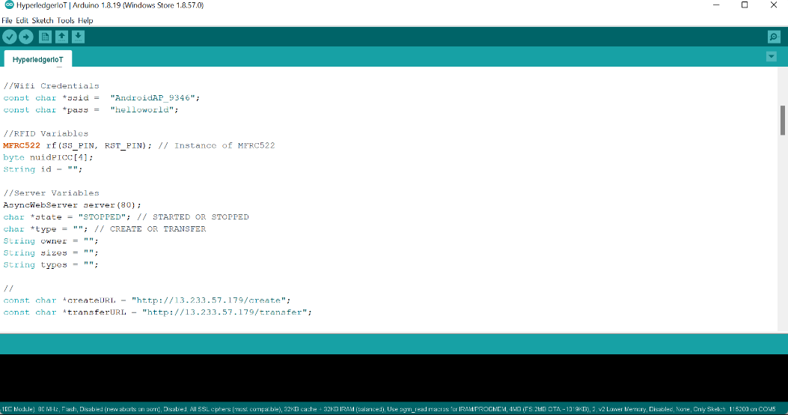

**Figure 1:** ESP8266 Programming with Arduino IDE

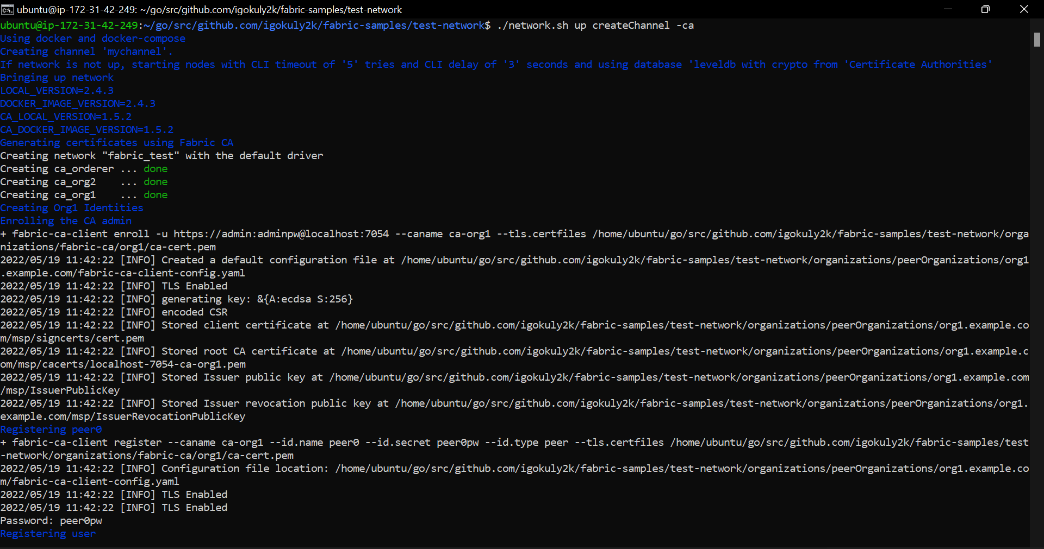

**Figure 2:** Creating Blockchain Sample Network using network.sh

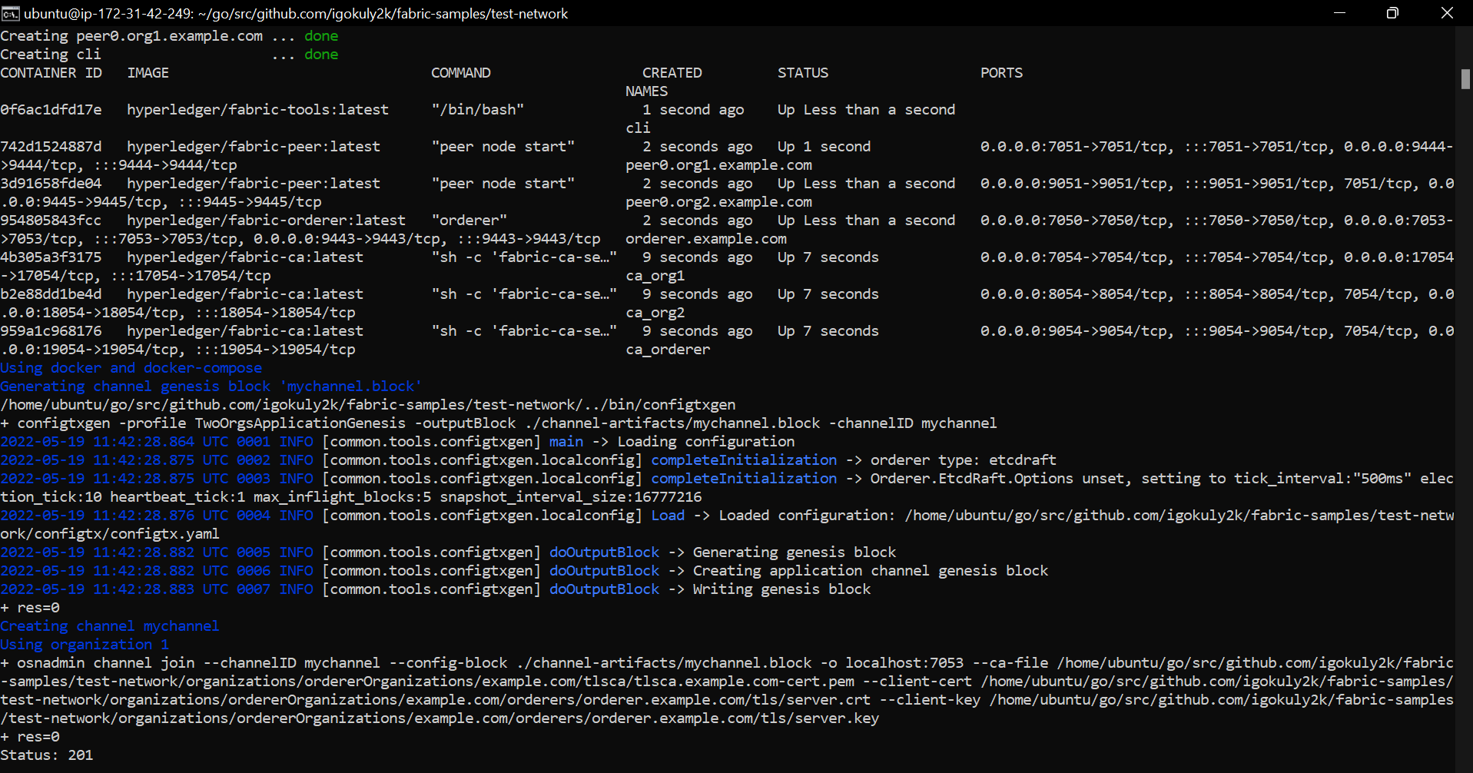

**Figure 3:** Docker Containers created using downloaded images

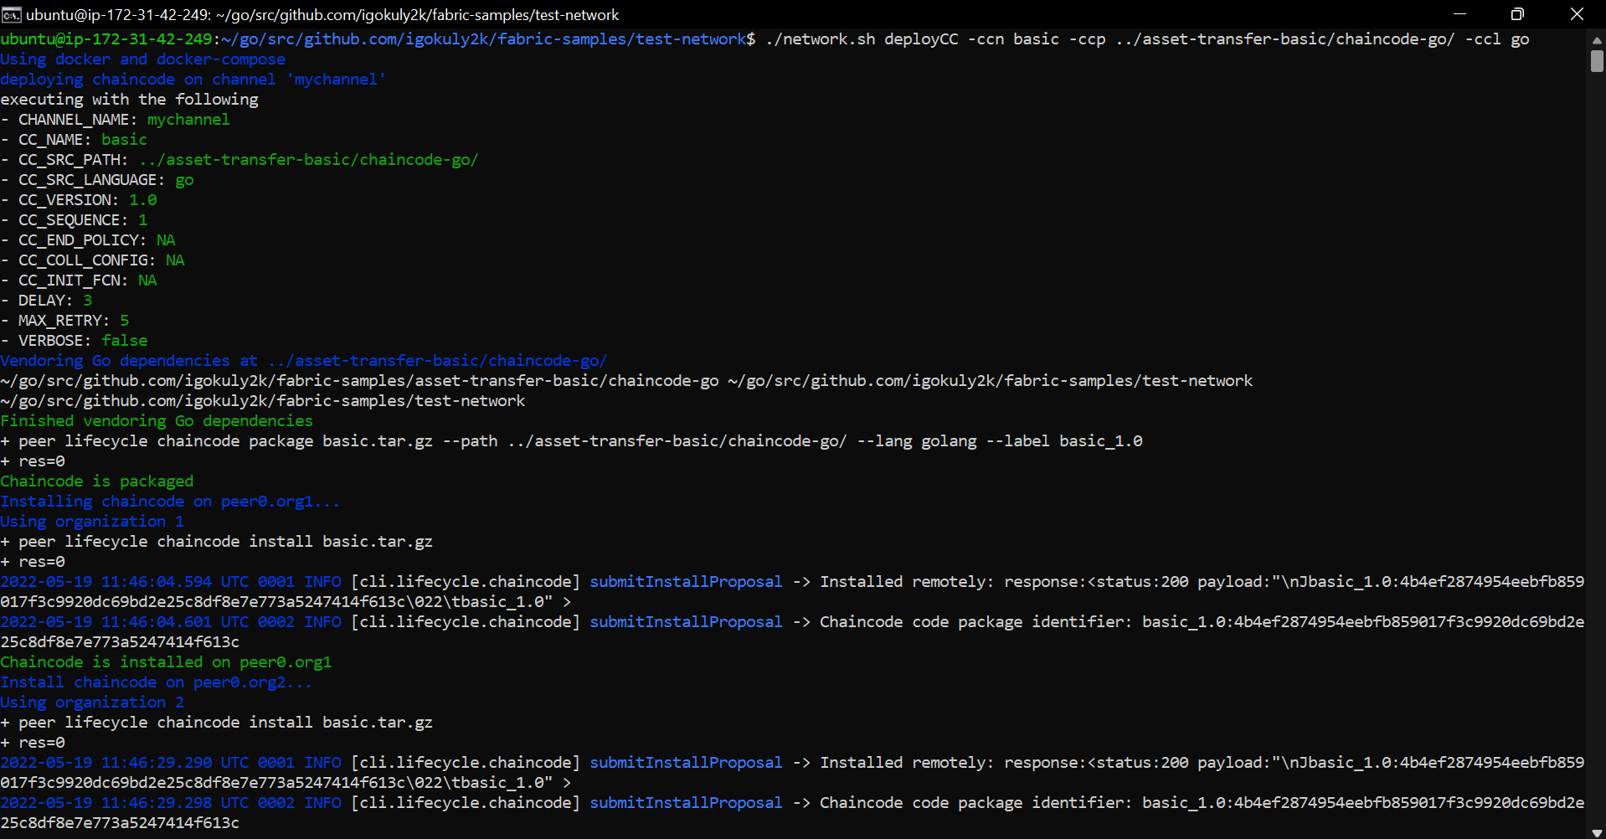

**Figure 4:** Chaincode Installation on peers

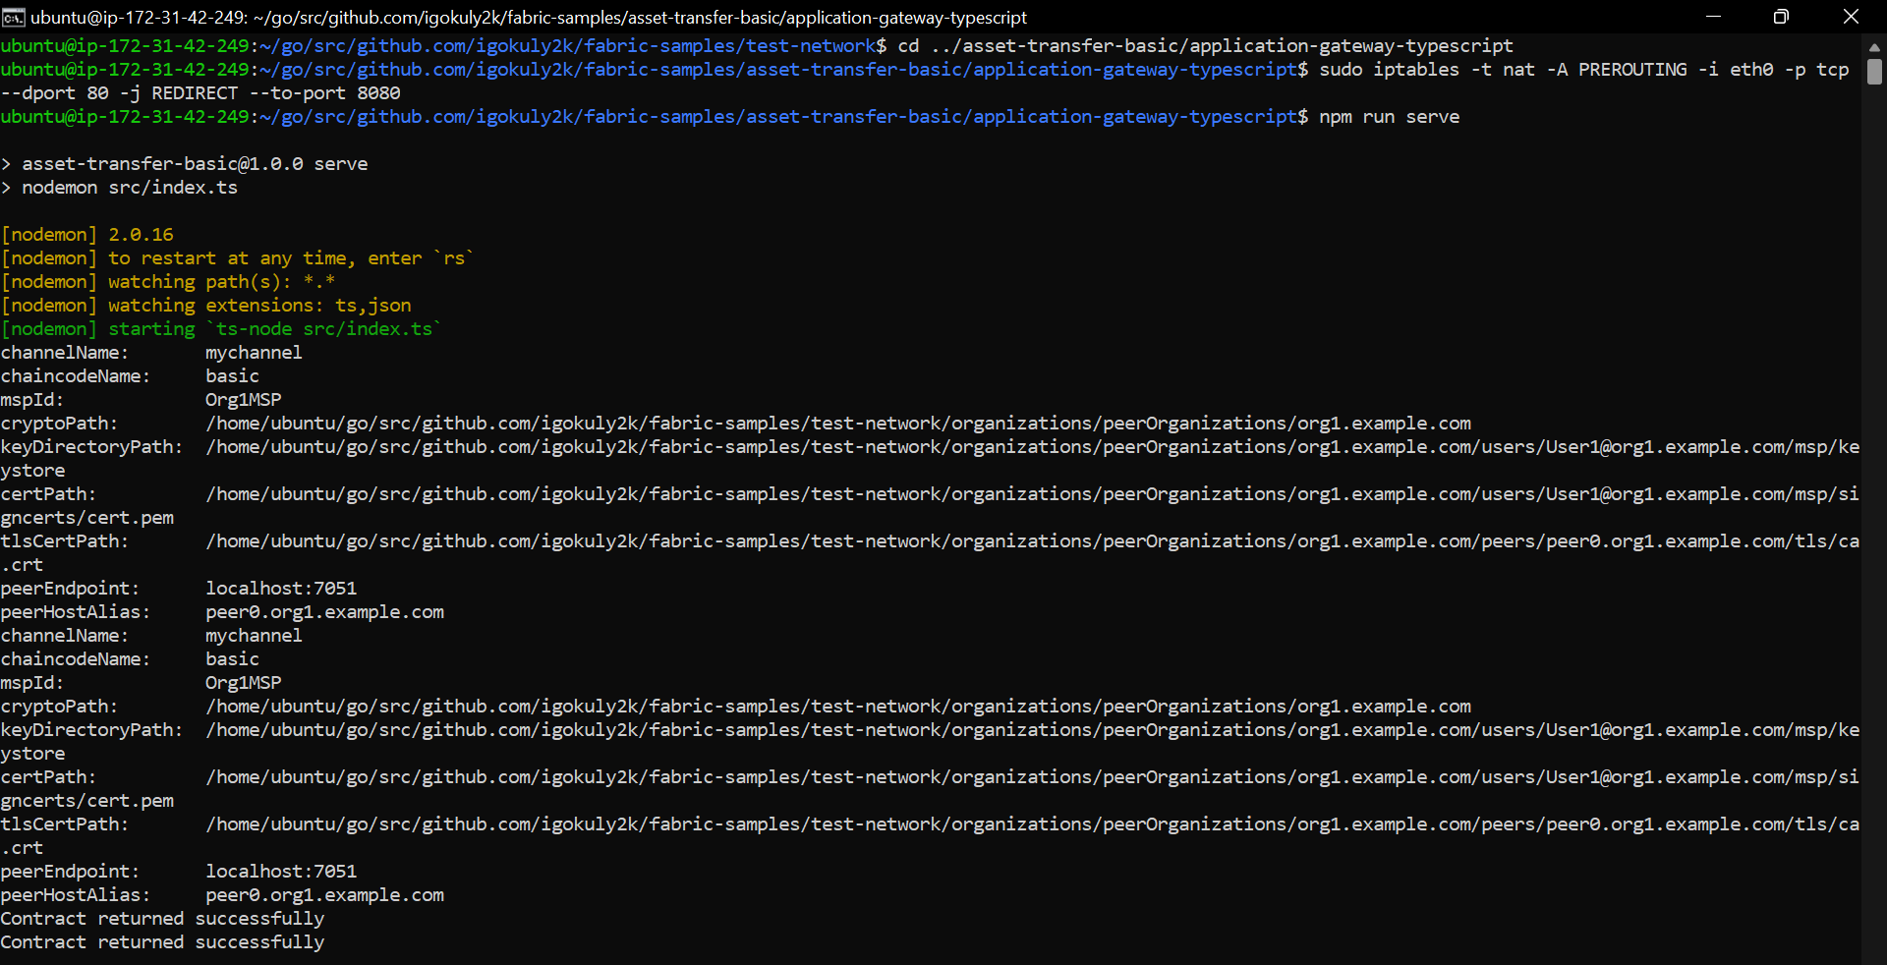

**Figure 5:** Application gateway compiled and running on port 8080

Figure 6. ESP8266 Interfaced with RFC522

1. **CONCLUSION AND FUTURE WORK**

Proof of Concept on functionalities of PDS using Hyperledger Fabric makes us to confirm that Permissioned Blockchain Infrastructures are helpful in inducing more transparency, traceability and accountability in food logistics and supply chain industry. Blockchain would fortify trust among organizations involved in the chain and consumers would be aware of the product and its lifecycle. Blockchain Infrastructures can be used as catalyst for Artificial Intelligence decisions, and this would give way for efficient, frugal, optimized logistics. The proof of concept can be scaled to production, and this would make sure that the intended right product reaches the consumer. [11].

1. **REFERENCES**

[1] Satoshi Nakamoto,"Bitcoin: A Peer-to-Peer Electronic Cash System",www.bitcoin.org., 2008

[2] Melanie Swan,"Blockchain Blueprint for a New Economy",Published by O’Reilly Media, Inc.,2015

[3] GUIDO PERBOLI, STEFANO MUSSO, MARIANGELA ROSANO,"Blockchain in Logistics and Supply Chain: A Lean

Approach for Designing Real-World Use Cases”, IEEE,2018

[4] Reshma Kamath,"Food Traceability on Blockchain: Walmart’s Pork and Mango Pilots with IBM",

The JBBA,2018

[5] Giorgio Alessandro Motta, Bedir Tekinerdogan and Ioannis N. Athanasiadis,"Blockchain Applications in the

Agri-Food Domain: The First Wave",Frontiers in Blockchain,2020

[6] Kok Yong Chan,Johari Abdullah,Adnan Shahid Khan,"A Framework for Traceable and Transparent Supply

Chain Management for Agri-food Sector in Malaysia using Blockchain Technology”, IJACSA,2019

[7] Rocha T, Costa P, Sousa V,Coelho P, Sousa F, Cardoso N,"SmartAgriChain: A Blockchain Based Solution for Agri food Certification and Supply Chain Management",International Journal of Environment, Agriculture and Biotechnology,2021

[8] Malni Kumarathunga,"Improving Farmers’ Participation in Agri Supply Chains with Blockchain and Smart Contracts”, IEEE,2020

[9] Sini V. Pillai, Vipin H., Anand Mohan, Shruthi Dileep A,"Infusing Blockchain in Supply Chain Operations

of a Public Distribution System",Journal of Supply Chain Management Systems,2020

[10] Sandeep Kumar Singh, Mamata Jenamani , Diptiman Dasgupta & Suman Das,"A conceptual model for Indian public distribution system using consortium blockchain with on-chain and off-chain trusted data",Information Technology for Development,2020

[11] Himani Mishra,Prateek Maheshwari,"Blockchain in Indian Public Distribution System: a conceptual framework to prevent leakage of the supplies and its enablers and disablers",ResearchGate,2021

[12] Hyperledger Fabric Documentation